CSA47 – Deep Learning
Name: Thikkavarapu Sanhith Register No.: 192311228

Experiment 6: Gradient Descent, SGD, Momentum and Adam Comparison
Question
Problem Statement: A logistics company trains a delivery-time prediction model. Training is slow, and the engineering lead asks which optimiser converges fastest and most reliably. A delivery dataset with distance, traffic index, weight and time of day as inputs and delivery time as the target. The objective is to implement and compare batch GD, SGD, Momentum and Adam. Use NumPy, TensorFlow, Keras, Matplotlib.
Tasks:
- Implement batch GD, SGD and Momentum from scratch on a simple loss surface.
- Plot each optimiser’s path on a 2-D loss contour.
- Train the same Keras regression model with SGD, SGD+Momentum and Adam.
- Plot loss against epochs for all optimisers.
- Vary the learning rate and note divergence or slow convergence.
Code
"""Experiment 6: Gradient Descent, SGD, Momentum and Adam Comparison"""
import time
import numpy as np
import matplotlib.pyplot as plt

# =========================== PART A: from scratch ===========================
# Loss surface: elongated bowl f(x, y) = x^2 + 10 y^2 (minimum at (0, 0))
def f(p): return p[0] ** 2 + 10 * p[1] ** 2
def grad(p): return np.array([2 * p[0], 20 * p[1]])

start = np.array([-4.0, 1.5])
steps = 60
rng = np.random.RandomState(0)

def batch_gd(lr=0.05):
p, path = start.copy(), [start.copy()]
for _ in range(steps):
p = p - lr * grad(p); path.append(p.copy())
return np.array(path)

def sgd(lr=0.05, noise=2.0): # noisy gradient mimics a mini-batch
p, path = start.copy(), [start.copy()]
for _ in range(steps):
g = grad(p) + rng.normal(0, noise, 2)
p = p - lr * g; path.append(p.copy())
return np.array(path)

def momentum(lr=0.05, beta=0.9):
p, v, path = start.copy(), np.zeros(2), [start.copy()]
for _ in range(steps):
v = beta * v - lr * grad(p)
p = p + v; path.append(p.copy())
return np.array(path)

def adam(lr=0.3, b1=0.9, b2=0.999, eps=1e-8):
p, m, v, path = start.copy(), np.zeros(2), np.zeros(2), [start.copy()]
for t in range(1, steps + 1):
g = grad(p)
m = b1 * m + (1 - b1) * g
v = b2 * v + (1 - b2) * g ** 2
p = p - lr * (m / (1 - b1 ** t)) / (np.sqrt(v / (1 - b2 ** t)) + eps)
path.append(p.copy())
return np.array(path)

paths = {"Batch GD": batch_gd(), "SGD": sgd(), "Momentum": momentum(), "Adam": adam()}

# Task 2: contour plot with paths
xx, yy = np.meshgrid(np.linspace(-5, 5, 200), np.linspace(-2, 2, 200))
zz = xx ** 2 + 10 * yy ** 2
plt.figure(figsize=(9, 5))
plt.contour(xx, yy, zz, levels=30, cmap="gray", alpha=0.6)
for (name, pth), c in zip(paths.items(), ["tab:blue", "tab:orange", "tab:green", "tab:red"]):
plt.plot(pth[:, 0], pth[:, 1], "o-", ms=3, color=c, label=name)
plt.plot(0, 0, "k*", ms=15)
plt.legend(); plt.title("Optimiser paths on f(x,y)=x^2+10y^2"); plt.xlabel("x"); plt.ylabel("y"); plt.show()

plt.figure(figsize=(7, 4))
for name, pth in paths.items():
plt.plot([f(p) for p in pth], label=name)
plt.yscale("log"); plt.xlabel("Step"); plt.ylabel("Loss"); plt.legend(); plt.title("Loss per step (from scratch)"); plt.show()

# =========================== PART B: Keras ==================================
import tensorflow as tf
from tensorflow import keras
tf.random.set_seed(42); np.random.seed(42)

# Synthetic delivery data
n = 2000
distance = np.random.uniform(1, 30, n)
traffic = np.random.uniform(0, 10, n)
weight = np.random.uniform(1, 50, n)
tod = np.random.uniform(0, 24, n)
rush = np.exp(-((tod - 9) ** 2) / 8) + np.exp(-((tod - 18) ** 2) / 8)
time_min = 10 + 2.0 * distance + 1.5 * traffic * (1 + rush) + 0.3 * weight + np.random.normal(0, 3, n)

X = np.column_stack([distance, traffic, weight, tod])
X = (X - X.mean(0)) / X.std(0)
y = (time_min - time_min.mean()) / time_min.std()
split = int(0.8 * n)
X_tr, X_te, y_tr, y_te = X[:split], X[split:], y[:split], y[split:]

def build():
return keras.Sequential([keras.layers.Input((4,)),
keras.layers.Dense(32, activation="relu"),
keras.layers.Dense(16, activation="relu"),
keras.layers.Dense(1)])

def train(opt, epochs=40):
m = build(); m.compile(optimizer=opt, loss="mse")
t0 = time.time()
h = m.fit(X_tr, y_tr, validation_data=(X_te, y_te), epochs=epochs, batch_size=32, verbose=0)
return h.history, time.time() - t0

configs = {
"SGD (lr=0.01)": keras.optimizers.SGD(0.01),
"SGD+Momentum (0.9)": keras.optimizers.SGD(0.01, momentum=0.9),
"Adam (lr=0.001)": keras.optimizers.Adam(0.001),
}
plt.figure(figsize=(8, 5))
for name, opt in configs.items():
hist, t = train(opt)
plt.plot(hist["loss"], label=f"{name}")
print(f"{name:22} final train loss {hist['loss'][-1]:.4f} | val loss {hist['val_loss'][-1]:.4f} | {t:.1f}s")
plt.xlabel("Epoch"); plt.ylabel("MSE loss"); plt.yscale("log")
plt.title("Keras: loss vs epochs"); plt.legend(); plt.grid(alpha=0.3); plt.show()

# Task 5: learning-rate sweep
fig, ax = plt.subplots(1, 2, figsize=(13, 4.5))
for a, (opt_name, make_opt, lrs) in zip(ax, [
("SGD", lambda lr: keras.optimizers.SGD(lr), [0.0001, 0.001, 0.01, 0.1, 1.0, 5.0]),
("Adam", lambda lr: keras.optimizers.Adam(lr), [0.00001, 0.0001, 0.001, 0.01, 0.1, 1.0])]):
for lr in lrs:
hist, _ = train(make_opt(lr), epochs=30)
final = hist["loss"][-1]
status = "DIVERGED" if (not np.isfinite(final) or final > 10) else ("slow/unstable" if final > 0.2 else "ok")
print(f"{opt_name} lr={lr:<8} final loss={final:.4f} -> {status}")
a.plot(hist["loss"], label=f"lr={lr}")
a.set_yscale("log"); a.set_title(f"{opt_name}: learning-rate sweep")
a.set_xlabel("Epoch"); a.set_ylabel("Loss"); a.legend(fontsize=8)
plt.tight_layout(); plt.show()
Output
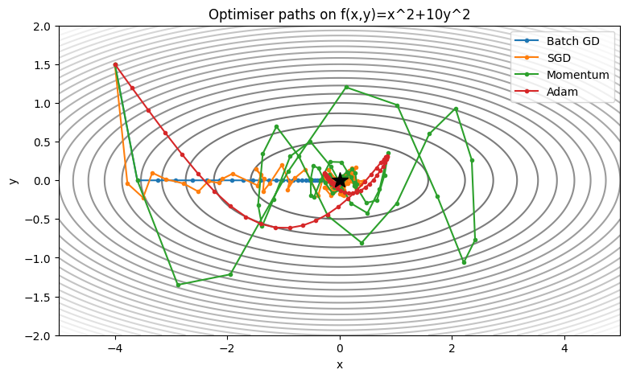
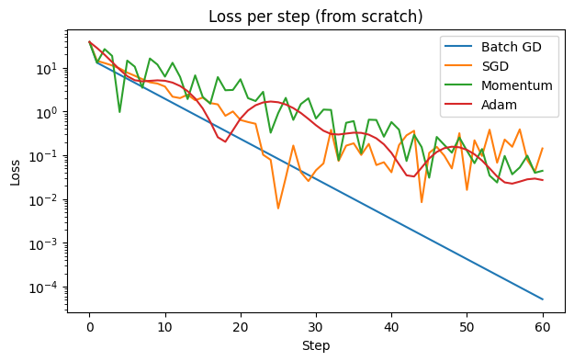
SGD (lr=0.01) final train loss 0.0427 | val loss 0.0491 | 10.4s
SGD+Momentum (0.9) final train loss 0.0391 | val loss 0.0473 | 9.7s
Adam (lr=0.001) final train loss 0.0388 | val loss 0.0467 | 10.2s
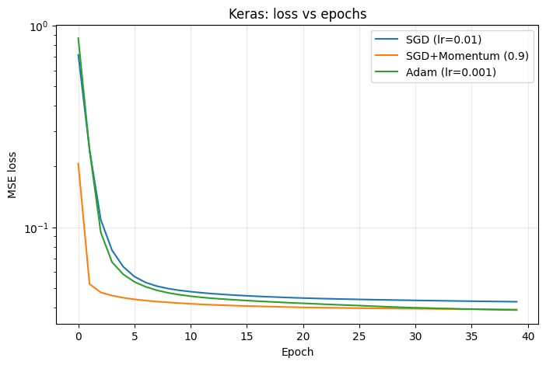
SGD lr=0.0001 final loss=0.8414 -> slow/unstable
SGD lr=0.001 final loss=0.0776 -> ok
SGD lr=0.01 final loss=0.0447 -> ok
